



Android Code Test

 simple Android application that consumes data from GIPHY

Willie Tsang | [wtsang01@gmail.com](mailto:wtsang01@gmail.com) | 6467195602| 11/5/2016

# Android Code Test

*The goal is to create a simple Android application that consumes data from an API and renders it for the user to view. Requirements are below.*

*\* Use the Giphy API (*[*https://github.com/Giphy/GiphyAPI#trending-gifs-endpoint*](https://github.com/Giphy/GiphyAPI#trending-gifs-endpoint)*) to get a list of results for a search query.*

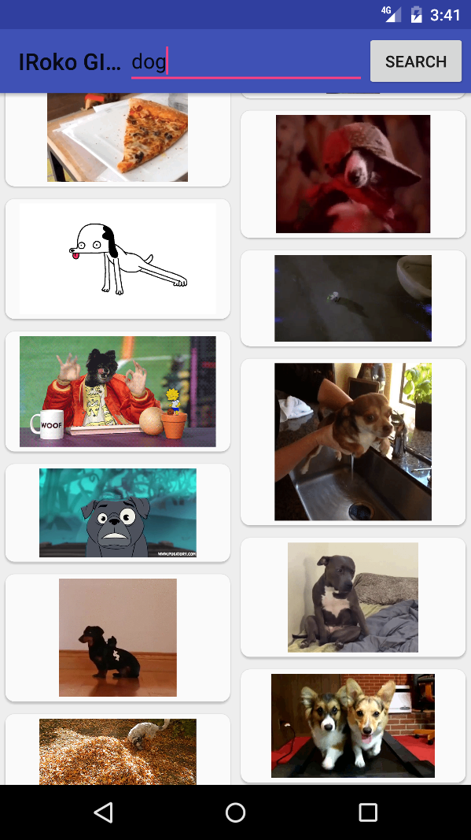

**Above searched ‘dog’ results and clicking search button. The activity will first load preview images, once that is done, it will load the .gif image to ensure the responsiveness.**

*\* The results should show in a staggered grid with infinite scroll*

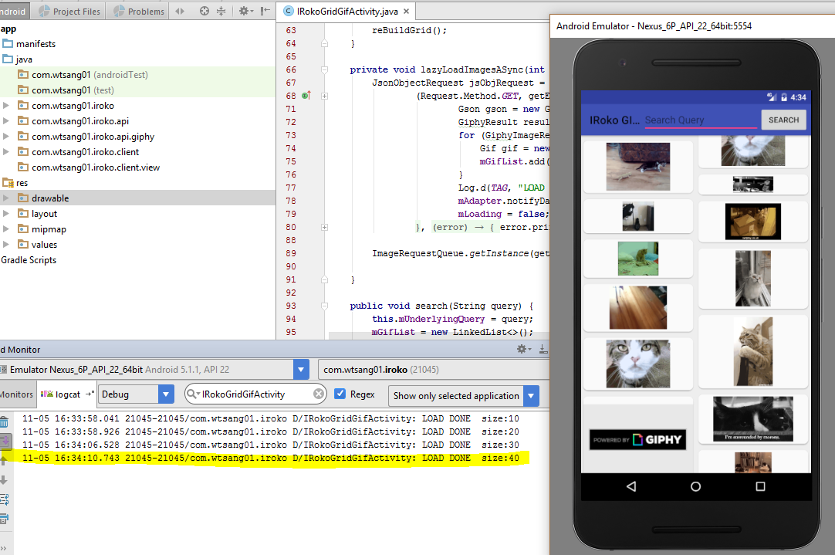

**With bucket size of 10, it will load infinitely. Loading is also async.**

*\* The results should use an image library for image/cache management*

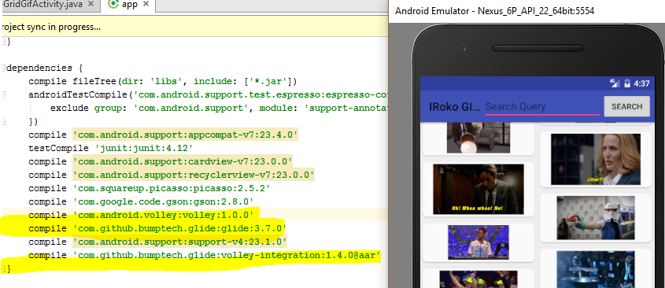

**Using Glide,Volley and its intergration library for primary image/cache management.**

*\* The user should be able to change the search query to see different results*

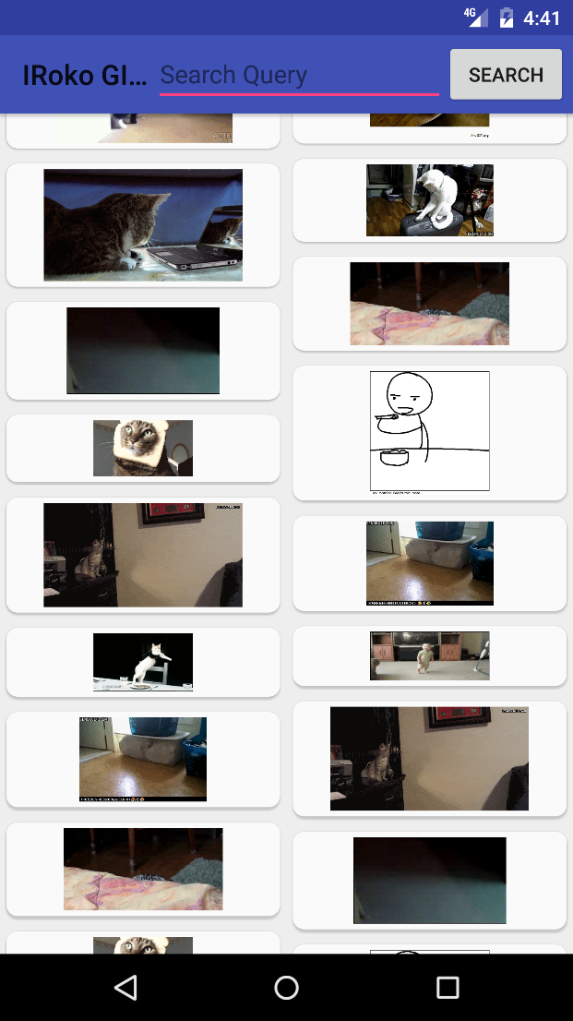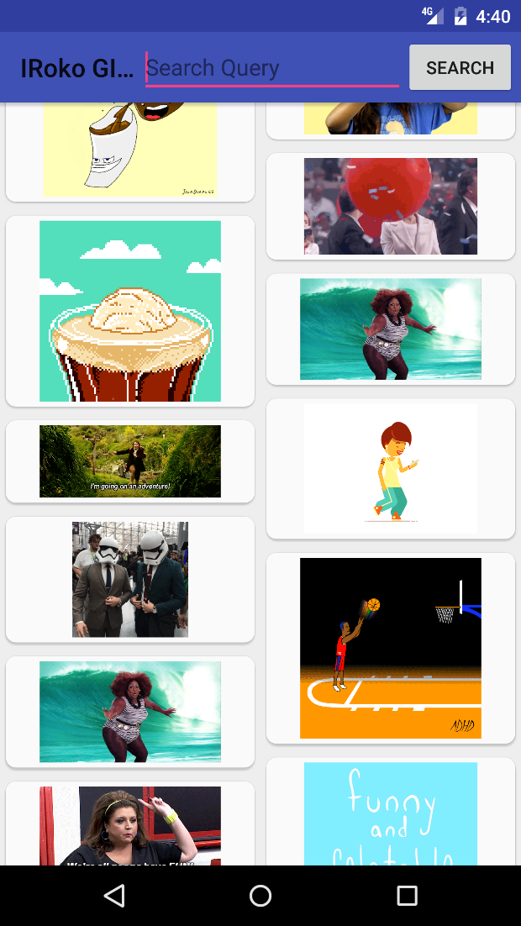

**On the left, is when application starts, it will look up ‘funny cat’ , on the right, after I type in ‘fun’ and click search, it will show ‘fun’ gif instead.**

*\* Upon tapping a result, it should show another activity with the higher quality GIF*

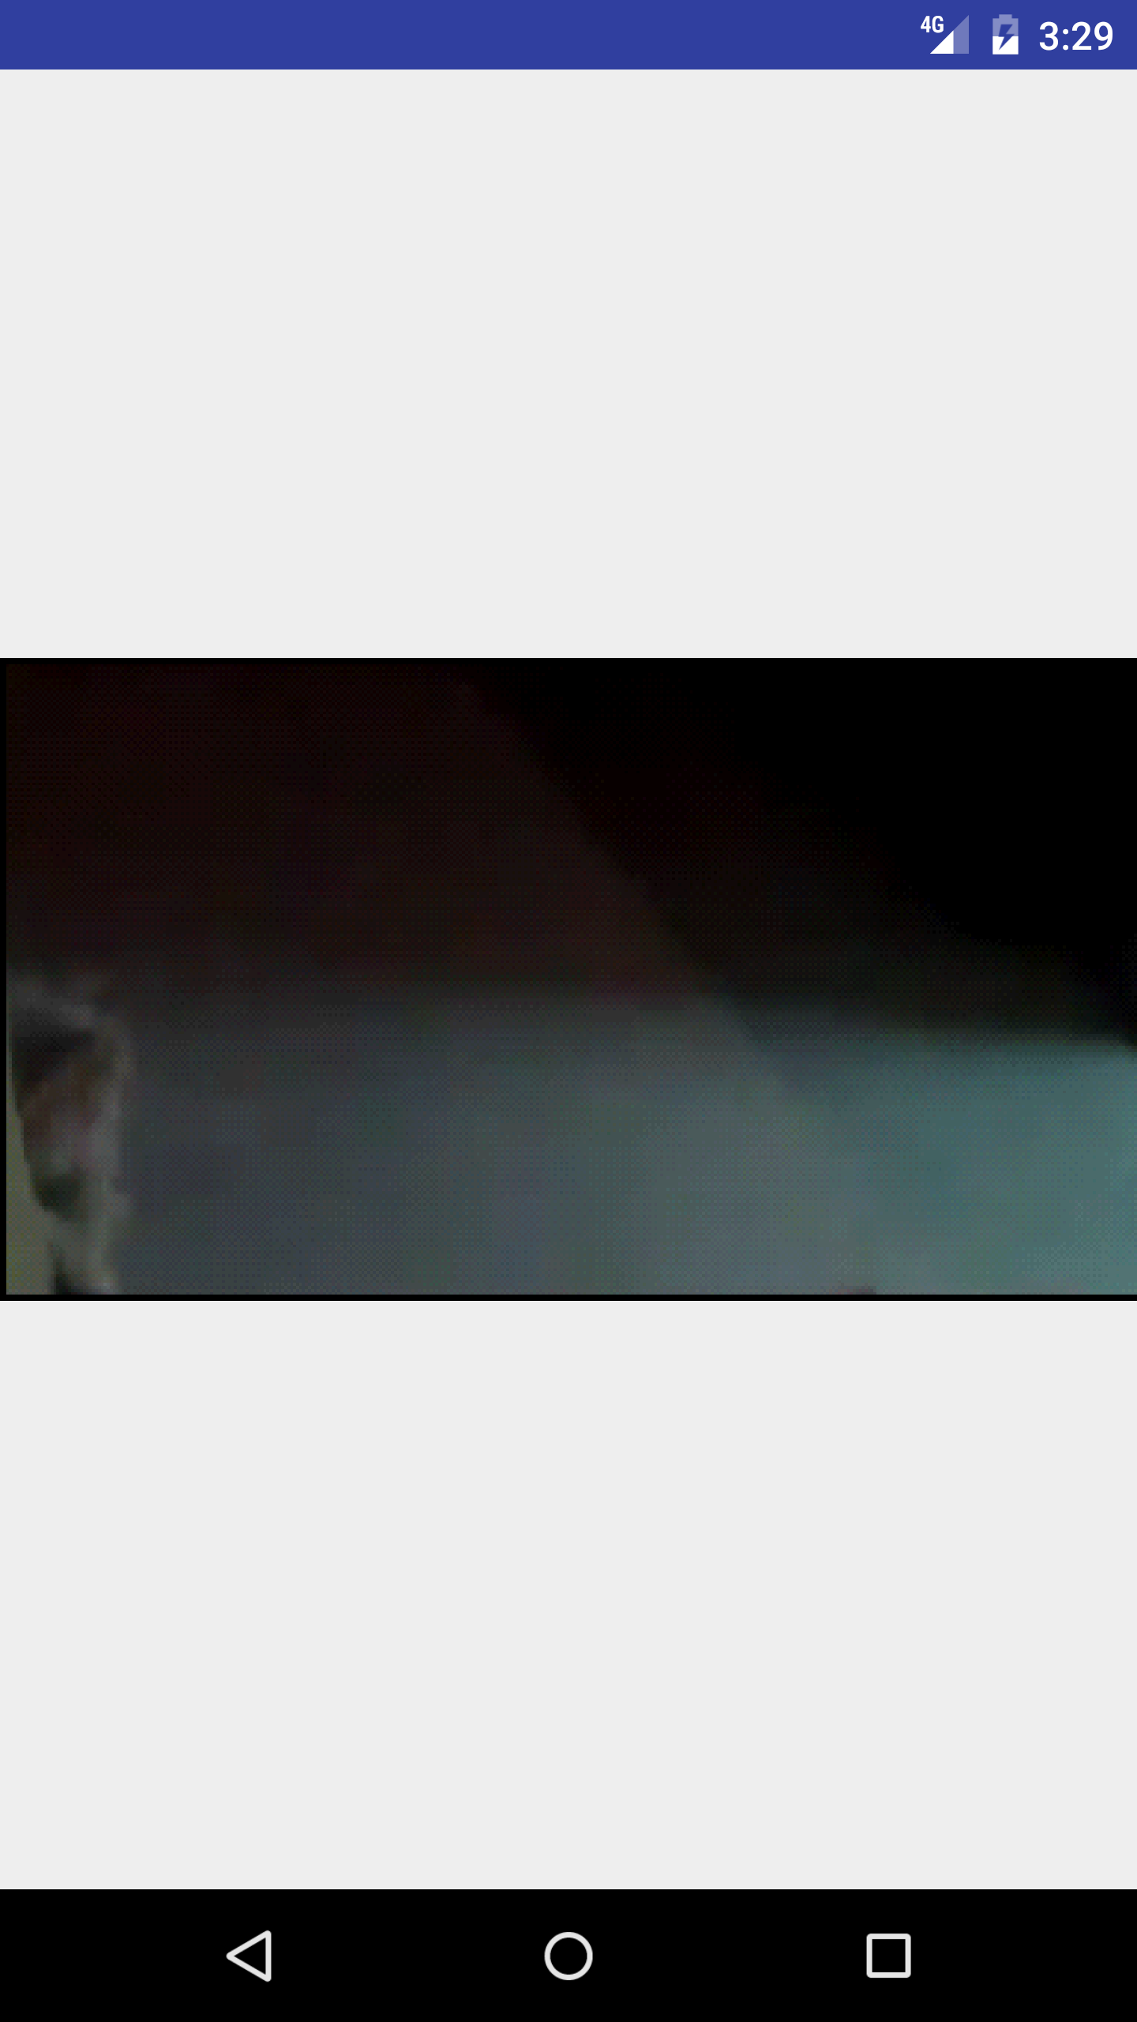

***After tapping into a gif, it will start a new activity and load a full sized .gif. Throughout the application, orientation changes are also handled.***